Anapest

🔹 What is Anapest
# Source: Chatgpt (GPT-4-turbo) at [8/3/2025]
An anapest is a metrical foot composed of three syllables:
- The first two syllables are unstressed, and the third is stressed:
◡ ◡ —
This creates a rising, galloping, or rolling rhythm, often used for energetic or dramatic effect.

✅ Syllable Pattern:
# Source: Chatgpt (GPT-4-turbo) at [8/3/2025]
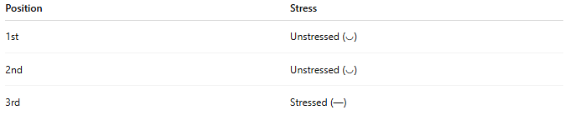
Position | Stress
1st | Unstressed (◡)
2nd | Unstressed (◡)
3rd | Stressed (—)

✅ Examples of Anapestic Phrases:
# Source: Chatgpt (GPT-4-turbo) at [8/3/2025]
- in the DARK
- on the RUN
- with a SMILE
- at the DOOR
These follow the ◡ ◡ — rhythm, with emphasis landing at the end.

✅ Function in Poetry:
# Source: Chatgpt (GPT-4-turbo) at [8/3/2025]
The anapest is common in:
- Anapestic meter, especially anapestic trimeter (3 anapests per line)
- Limericks, comic verse, and light poetry
- Narrative poetry with movement or action

✅ Famous Example – Anapestic Trimeter:
# Source: Chatgpt (GPT-4-turbo) at [8/3/2025]
From Clement Clarke Moore’s "’Twas the Night Before Christmas":
’Twas the NIGHT / before CHRIST / mas, and ALL
◡ ◡ — / ◡ ◡ — / ◡ ◡ —
Each foot is an anapest, contributing to the lively, rhythmic flow.

✅ Contrast with Other Feet:
# Source: Chatgpt (GPT-4-turbo) at [8/3/2025]
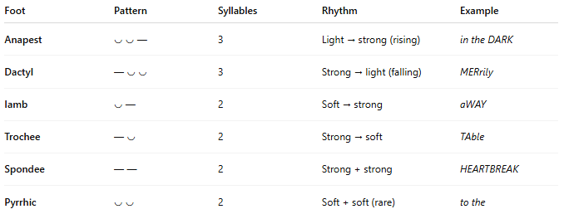
Foot | Pattern | Syllables | Rhythm | Example
Anapest | ◡ ◡ — | 3 | Light → strong (rising) | in the DARK
Dactyl | — ◡ ◡ | 3 | Strong → light (falling) | MERrily
Iamb | ◡ — | 2 | Soft → strong | aWAY
Trochee | — ◡ | 2 | Strong → soft | TAble
Spondee | — — | 2 | Strong + strong | HEARTBREAK
Pyrrhic | ◡ ◡ | 2 | Soft + soft (rare) | to the

📝 Summary:
# Source: Chatgpt (GPT-4-turbo) at [8/3/2025]
- Anapest = two unstressed + one stressed syllable (◡ ◡ —)
- Produces a galloping, rising rhythm
- Common in light verse, limericks, action poetry
- Opposite of the dactyl (— ◡ ◡)

